# Tesla Charging Log Spreadsheet

This spreadsheet keeps track of your charging statistics. It attempts to be more accurate and keep a better record than the Tesla app.

## Summary Tab

Monthly summary of statistics.

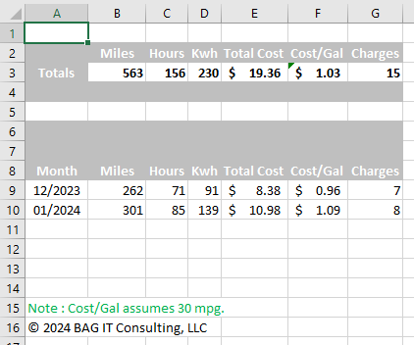

## Charge_Calculator Tab

Set the number of miles and the Odometer reading and press either the “Hour Charge” or “Percentage Charge” buttons to record a row in the monthly spreadsheet. On the first time you use the log in a new month, the spreadsheet will generate a new monthly sheet and insert a new row in the Summary Tab for the new month. Use the “Clear Current Row” button to remove a row recorded today from the monthly log Tab.

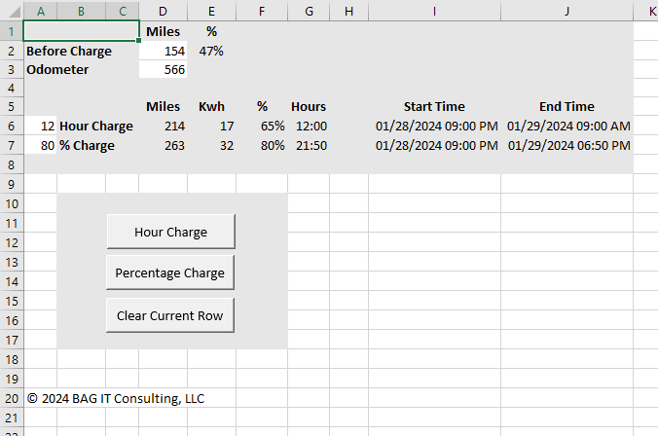

## Charge_Calculator Tab (Hidden Columns – Configuration and Settings)

Configuration and Settings are recorded in Hidden columns in the Charge Calculator Tab.

I had a real issue determining Kw of charging per hour. In the first calculation, I took the maximum number of miles and the maximum kwh for the entire battery pack and tried to use that to calculate the kw per hour. In the second calculation, I multiplied volts by amps to get kw. Both of these calculations gave me too low an estimate for kwh when charging. I bought a watt meter from Amazon and determined the kwh for a charging session and just divided the numbers to get the value that is much higher than expected but gives a useful estimate. That third value is what is used in to calculate kwh.

The app drops charging statistics after 31 days or a year. It doesn’t give you any other options. I recommend using a Watt meter to track your electricity usage. Or you just don’t know how much you are using.

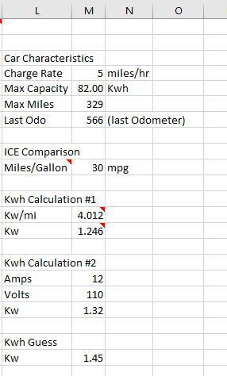

## Charging_Log-yyyy-m Tab

This is the layout of the monthly log sheet. When I was filling this out manually, the green rows were those that I needed to fill in before starting charging and the red ones were the ones I couldn’t fill out until charging was done. The green rows should be correct. The red rows should be reviewed after the charge is finished. The values out of the charge calculator are estimates and should be correct but may not match the values in the app every time. The blue columns are formulas and should never be touched.

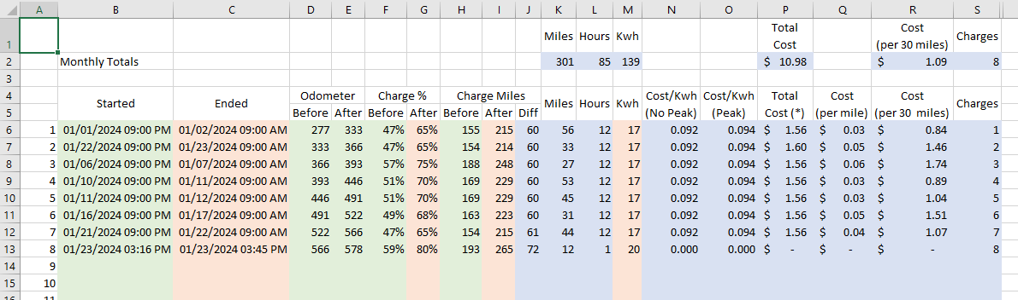

## Charging_Log-yyyy-m Tab (Hidden Columns)

These columns

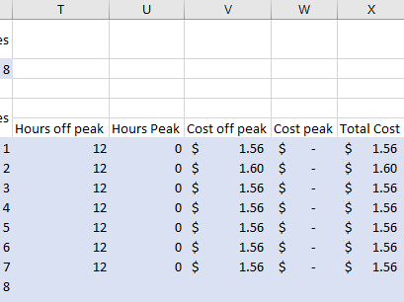

## License Terms Tab

This tab is self-explanatory. The MIT Open Source license allows any use of the spreadsheet as long as the copyright and license information is distributed along with the spreadsheet.

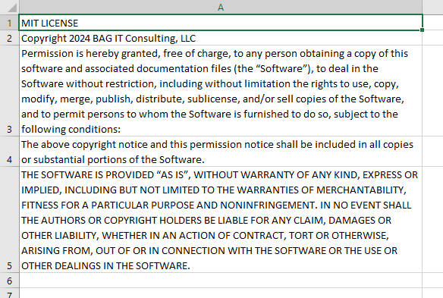

## Release Notes Tab

This page shows features added in each release of the spreadsheet.

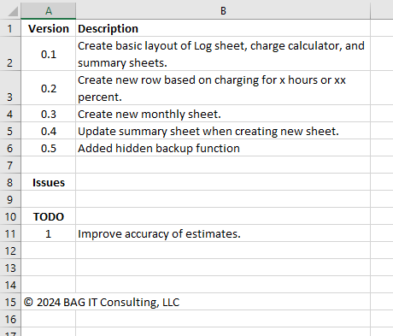

## License Terms

MIT LICENSE

Copyright 2024 BAG IT Consulting, LLC

Permission is hereby granted, free of charge, to any person obtaining a copy of this software and associated documentation files (the “Software”), to deal in the Software without restriction, including without limitation the rights to use, copy, modify, merge, publish, distribute, sublicense, and/or sell copies of the Software, and to permit persons to whom the Software is furnished to do so, subject to the following conditions:

The above copyright notice and this permission notice shall be included in all copies or substantial portions of the Software.

THE SOFTWARE IS PROVIDED “AS IS”, WITHOUT WARRANTY OF ANY KIND, EXPRESS OR IMPLIED, INCLUDING BUT NOT LIMITED TO THE WARRANTIES OF MERCHANTABILITY, FITNESS FOR A PARTICULAR PURPOSE AND NONINFRINGEMENT. IN NO EVENT SHALL THE AUTHORS OR COPYRIGHT HOLDERS BE LIABLE FOR ANY CLAIM, DAMAGES OR OTHER LIABILITY, WHETHER IN AN ACTION OF CONTRACT, TORT OR OTHERWISE, ARISING FROM, OUT OF OR IN CONNECTION WITH THE SOFTWARE OR THE USE OR OTHER DEALINGS IN THE SOFTWARE.

## Contact Information

Any questions or issues? Email [bagitconsultingllc@gmail.com](mailto:bagitconsultingllc@gmail.com).